Out: 14.3.2018
In: 27.4.2018
Individual reports

TBA4245: Assignment no. 5, Network analyses. 2018
NB: The “light” version of assignment no. 5:
The last years the students and the teachers agreed that only answering the questions related to the printouts is Ok for getting the assignment approved. Reason: To reduce the total workload at the end of the semester. And, understanding a printout from the reliability analyses is an important goal in this course. Use the printouts in the table on page 2 (the doc files), the documentation files. For ev. later use, the full text is kept.
NB: There are some paper versions of the doc files from Gisline in the in/out box of the course close to my office. Terje S.
In this year’s version of the assignment text the compulsory questions are marked with yellow.
Text books etc., found on Blackboard:
- Example exercises no. 9 (gross error test), 10 (global test), 11 (internal and external reliability analysis), are covering main topics in this assignment.
- Skogseth et al: “Reliability analysis of network of control points”. Chapter B (Analysis and Reliability). Including examples, also examples by use of the land surveying program Gisline. Probably easier to understand the methods compared to Gjevestads note, see below
- Gjevestad: “Multiple T-test for quality control”. Both English and Norw. versions. Matrices are used, more practical in use than the methods used in the textbook above. Covering all tests in the reliability analysis. This method is used in the Norw. land surveying programs Gisline and Gemini. See example exercises no. 9 and 11 for numerical examples.
- Ghilani: “Adjustment computations”. Chapter 14.2-14.4 (Horizontal 2D adjustment with distances (trilateration)). Ch. 19 (Error ellipse). Ch. 20 (Constraint equations). Ch. 21.4-6 and 21.9 (Blunder detection in horizontal networks), this chapter is based on chapter 5 (Statistical testing).
- Leick: “GPS Satellite Surveying”. Chapter 4: Least squares Adjustments”. See: Ch. 4.10 Reliability (NB: different notation/sign in the observation equation: v = Ax + l), well written text at pp 151-153. Chapter 4.11 (Blunder detection). Ch. 4.9.5-4.9.6 (Error ellipses).
- Holsen/Skogseth: “Mathematical statistics”. Ch. 3 (accuracy measures), 4.2 (Error propagation law, variance-covariance propagation law), 5.3 and 5.4 (weighted mean).
Grading: Passed/not passed
Report: Individual report. Submit the report to Blackboard.
Tasks:
See chapter 3 for the compulsory part of the assignment. There you will find questions covering:
- Gross error test (Blunder test), Global test, Internal reliability, External reliability

Introduction
The original purpose of assignment no. 5 is practice software programming in order to get a deeper understanding of gross error testing and reliability analysis. Matlab or similar program.
In this light version of the assignment the purpose of this assignment is to show that you manage and understand the methods used in, and the printouts from, reliability analyses on a network of control points.
Based on the note, “Multiple T-test for quality control” of Jon Glenn Gjevestad, you should be able to make calculations for answering the questions. Note that the l-vector in the translated Gjevestad paper is identical to the f-vector in the NTNU Geomatics compendia.
Include your computed values in a short report. Explain all your results.
If you find serious discrepancies or other problems under the calculations, try to give an explanation of reason and why things went wrong, especially if you spend too much time trying to figure out the problems.
Emphasize to communicate the calculations clearly. Matrix printouts, scripts from Matlab, various sets of observations and variance-covariance matrices etc. should all be included in your report.
Contents
Introduction 1
1D 2
1. Example exercises. NB: Voluntary this year. 2
1.1 Example exercise no. 9: Gross error detection 2
1.2 Example exercise no. 11: Internal and external reliability 2
2D 3
2. Method: Trilateration. Theory for the questions in chapter 3 3
2.1 General 2D distance observation equation 3
2.2 Additional unknowns 4
3. 2D Network analysis Questions 5
3.1 Adjustment 5
3.2 Gross error test 6
3.3 Global test 7
3.4 Internal reliability (free network adjustment) 7
3.5 External reliability (free or constrained network?) 8
3.5.1 Internal reliability (IR), results constrained network: 9
3.5.2 External reliability (ER), 1 point involved, free and constrained network. 11
3.5.3 External reliability (ER), constrained adjustment), 2 and 3 points involved 12
3.6 The rest is voluntary 12

1D

Example exercises. NB: Voluntary this year.
Example exercises no. 9, 10, and 11 are simple examples to understand better the methods of gross error detection, global test, and internal and external reliability. Use Matlab to solve no. 9 and 11, or check the solutions on Blackboard.

Example exercise no. 9: Gross error detection
Do example exercise no. 9 with the extend A-matrix method described in the note from Jon Glenn Gjevestad.

Example exercise no. 11: Internal and external reliability
Do example exercise no. 11 with the method described in the note from J. G. Gjevestad.

2D
A 2D-network analysis has been performed on the network in the figure below, by using the Gisline software. Printouts for the five steps of the 2D network analysis are stored in separate text files, see the table below. The idea is that you can compare and recognize results while you are developing your own software. If you have access to Gisline, you can unzip the database: 2D_trilateration.zip and do the analysis yourself. Example exercise no. 12 at Blackboard is based on Gisline and is identical to assignment no. 5.
To avoid wasting time on text format problems, a Matlab-script: reading_mat is prepared for reading data. (from Gisline output files: A_c, Pd, and L) Data are reorganize to NTNU Geomatics matrix notations: A, P, f. These data files will be copied to Blacboard by request.

Overview data files at Blackboard:
Data files | File name | Note
Matlab script | Reading_mat.m | Reading_mat.m is a Matlab script that reads A_org, L and PD files from Gisline, rearrange and give matrices similar to NTNU compendia as output: A, P, and f
Gisline output file | A_org
Gisline output file | L
Gisline output file | PD
Gisline results etc.
Adjustment | 2D_constraint.dok | Results, documentation files, are text files. See zip file on Blackboard or paper copies in the out/in box.
Adjustment | 2D_free_adjustment.dok
Gross Error Test | 2D_gross_error_test.dok
Global Test | 2D_Global_test.dok
Internal reliability CI | 2D_internal_CI_method.dok
Internal rel. non central T | 2D_internal_non_central_T.dok
External Reliability | 2D_external_reliability.dok
Gisline survey database | 2D_trilateration.zip | Gisline landmåling project files
Gisline manual etc. |  | See example exercise no. 12

Method: Trilateration. Theory for the questions in chapter 3

General 2D distance observation equation
In this assignment, the observations are horizontal distances only. In geodesy this exercise is known as trilateration.
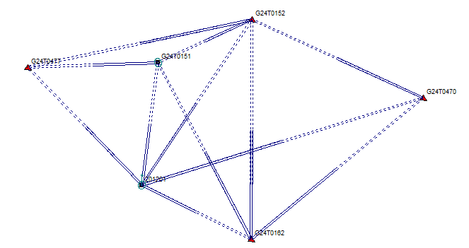
A general distance observation from A to B: (x=North, y=East). Linearization gives (1)

Derived in TBA4236 Theoretical: See Ghilani chapter 14 equations 14.1-14.3 in the Support literature folder on Blackboard.

Index zero indicates the use of approximate coordinates (x₀,y₀).
represents the distance computed from approximate coordinates.
The partial differentiates give coefficients in the design matrix A. With (n - e) > 0 a general observation equation for Least Squares Method is then:

, all obs. equations using matrices: V = AX - F

As an example, the first coefficient in the general linear observation equation is derived from:

The denominator of a₁ is l₀, and the numerator is the negative x-coordinate difference, so the first coefficient is in fact cosine of the plane bearing from point A to B multiplied with minus one. Equivalent for other coefficients, we get the known equation from theoretical geomatics:

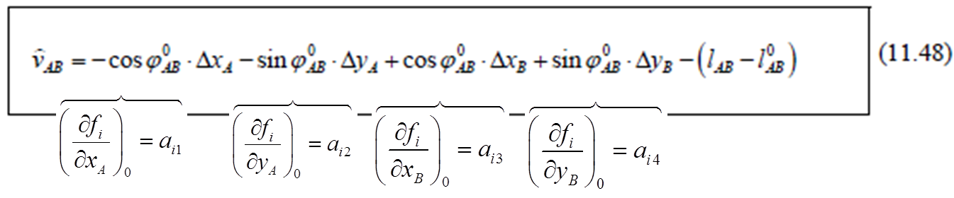

Additional unknowns
In addition to unknown point coordinates, additional unknowns for scale m, and rotation are commonly introduced in 2D or 3D adjustments. In the gross error test in sub chapter 3.2 an equation system including scale is used, so observables including scale will shortly be explained. The general observation equation including a scale parameter m is:
The partial differentiated which is used to compute coefficients for the last column in A related to the new unknown ∆m in the x-vector. Similar should a factor m also be considered for the other partial differentiated as e.g.
(2)

Initial values are used to compute the coefficients. A reasonable initial value for is 1, and one iteration is usually sufficient to solve for . So, setting before the last iteration, we find that the m in equation (2) can be ignored also.

2D Network analysis Questions
The actual questions this year are marked with yellow.

Adjustment
A constrained adjustment has been performed in order to compute coordinates for the two points 201201 and G24T0151. Full documentation is listed in file: 2D_constraint.dok

Computed coordinates (N, E, last iteration) and standard deviations of the unknown points, sN, sE:

POINT N E H sN sE sH
------------------------------------------------------------------------
201201 7032579.4802 570205.8018 0.0019 0.0018
G24T0151 7033994.2628 570391.2657 0.0022 0.0017

The observation equation (1) on page 4:
Show that the first coefficient for the observation from 201201 to G24T0151 is -0,991517.
Assume first that there are no gross errors, or problems with the given control points, so your final (constrained) adjustment gave the coordinates and standard deviations as listed above.

The correlation coefficient between N- and E- component of G24T0151: .
The weighted sum of error squares, Σpvv = 1.17089771 m².
Unknowns for G24T0151, are located as the 2 last elements in the x-vector. Corresponding 2∙2 cofactor matrix is:

Calculate the variance/covariance matrix of the estimated coordinates of point G24T0151. Show by calculations that the standard deviations on the estimated coordinates are s_{N} = 2,2 mm and s_{E} = 1,7 mm.

Show that the length of the semi axes in a standard error ellipse for the point G24T0151 is 2.2 mm (a in the dok-file). What is the direction of the main ellipse axis? (Not given in the dok-file.) Not lectured this year.

Gross error test
A free network (minimum constraints) adjustment is made in Gisline. Unknowns in parameter vector x are the coordinates of the 4 unknown points G24T0477, G24T0151, G24T0152, 201201, and the scale as an additional unknown.

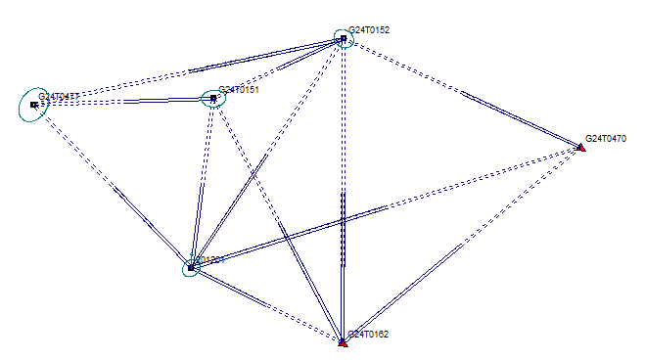

Show that the degrees of freedom for a minimum constrained/free adjustment is f = (n - e) = 3

Find the tabulated value of a multiple T-test, and show first that the numerical values of the parameters are f = 2 and alpha = 0.0021.

Now you can develop the Matlab script reading_mat.m further. If you run the script at the same folder where A_c, Pd and L from Gisline are stored, the matrix/array data will be:

- Design matrix A as you know from NTNU Geomatics compendia.
- Weight elements stored to a diagonal weight matrix P
- The constant terms in a f-vector, the unit is cm.

Results from Matlab: The estimated gross error, ∇ (nabla), and the estimated standard deviations on the gross error are, same sequence of the observations as in the printout from Gisline:

Est gross errors  nabla = -0.27 cm  nabla = 0.26 cm  nabla = -0.46 cm  nabla = 0.09 cm  nabla = -3.47 cm  nabla = 0.71 cm  nabla = 0.43 cm  nabla = -0.82 cm  nabla = 0.65 cm  nabla = -0.46 cm  nabla = -0.13 cm  nabla = -0.23 cm | Est std dev. gross errors  nabla_std.dev. = 0.56 cm  nabla_std.dev. = 0.56 cm  nabla_std.dev. = 0.60 cm  nabla_std.dev. = 0.62 cm  nabla_std.dev. = 1.06 cm  nabla_std.dev. = 0.22 cm  nabla_std.dev. = 0.40 cm  nabla_std.dev. = 0.25 cm  nabla_std.dev. = 0.45 cm  nabla_std.dev. = 0.66 cm  nabla_std.dev. = 0.84 cm  nabla_std.dev. = 1.48 cm

Perform a multiple T-test in order to find gross errors (outliers) among the observations according to Gjevestad part 2, 3 and 6.

Interpret and comment on the printout from the gross error test in Gisline.

Comment on the result of the test.

If you cannot find an outlier, fake an outlier by adding some centimeters to observation no. 9 (the 9th element in the f-vector). Which is the limit value to be added, for the observation 9 to be flagged as a gross error (outlier)? (remember to reset f before you continue)
NB: Must run Gisline (is voluntary). Ev. calculate an approximate value by using the test formula.

Global test
From: 2D_constraint_adjustment.DOK: Weighted sum of squared errors: 1.17089771
From: 2D_free_adjustment.DOK: Weighted sum of squared errors: 0.45468277
These values can also be found in the Dok file for the Global test, 2D-Global_test.DOK

NB: For the constrained network the calculations is done with no additional unknown(s): No additional unknown scale. The estimation of the free network showed that the scale is not significant different from 1, see the dok file. With control points measured with GNSS/GPS we normally set the scale factor to 1; the scale is known. But, some inconsistency between free and constrained estimation, should probably used a known scale for the free network as well, or not using scale in the gross error test.

Perform a global test to find out if assumed known control points are OK.
Show that the tabulated value of the test is 15.2627, and show that the numerical values of the test parameters are as listed in the Gisline printout.
Use the estimated value of the standard deviation of the unit weight.

Comment on the result of the test.

Internal reliability (free network adjustment)
Compute the redundancy matrix R.

Results from Matlab: The elements on the main diagonal of R are, same sequence of the observations as in the printout from Gisline:

Diagonal elements of the Redundancy matrix:
R element: ( 1, 1) = 0.2692
R element: ( 2, 2) = 0.3466
R element: ( 3, 3) = 0.1983
R element: ( 4, 4) = 0.4092
R element: ( 5, 5) = 0.0151
R element: ( 6, 6) = 0.3184
R element: ( 7, 7) = 0.3392
R element: ( 8, 8) = 0.3378
R element: ( 9, 9) = 0.2922
R element: (10,10) = 0.2382
R element: (11,11) = 0.1830
R element: (12,12) = 0.0529

(List and) explain the values of the diagonal elements of R, the redundancy numbers.
Use the confidence interval method according to Gjevestad part 4, and compute the Largest Remaining Outliers (LRE) for each observation.
First, find the tabulated value to be used in calculating the Largest remaining gross errors, and show that the numerical value of the tabulated value is 4,3027.
Then calculate the LRE’s, also by using the gross errors and the standard deviations of the gross errors from 3.2.

Comment on relations between LRE’s and redundancy numbers.

Interpret and comment on the printout from the gross error test in Gisline

Comment on the asterixs, *, in the Gisline printout from the internal reliability test.

External reliability (free or constrained network?)
The external reliability is based on LRE’s from internal reliability (IR). In chapter 3.4 the IR was calculated in a free network, but should for use in external reliability correctly be made with a constrained network.

Why use constrained network and not free network in the external reliability test?

Gisline printouts, general information:
Abbreviations used in Gisline:
M: Standard deviation
Observations:
R: Bearing (GPS), directions (total stations)
D: Distance
dH: Height difference

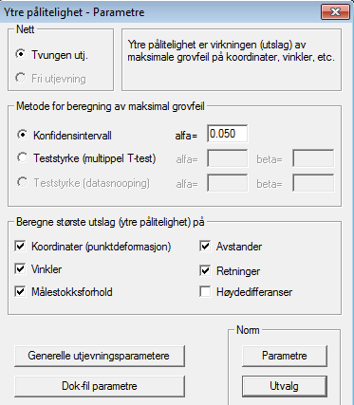
This is a screen shot from the external reliability parameter settings in the Gisline menu:

The Norwegian Standard request documentation from other effects than the maximum point deformation (2D coordinates). Three point connections angles (“Vinkler”) and scale variation (“målestokksforhold”) is compulsory.

Two point connections
«Avstander» =distances,
«Retninger» = directions
“Høydeforskjeller” = height differences

Three point conections
“Vinkler” = Angles,
“Målestokksforhold” = Scale variations,

Tolerances of the standard, the quality class no. 1 to class 4 of the standard Grunnlagsnett
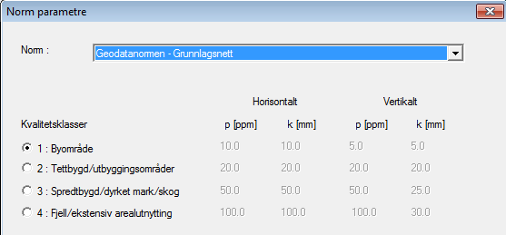

Internal reliability (IR), results constrained network:

Re-compute your LRE’s with the A-matrix and f-vector from the constrained network, given below.

f =
-0.103166741
0.180953081
-0.210612683
0.0281093512
-0.181600549
0.239170898
0.140183273
-0.294147107
0.229950258
0.265346663
0.425648958
-0.128578869

A =
-0.991516882000 -0.129977969000 0.991516882000 0.129977969000
-0.833294293000 -0.552829649000 0 0
0.444356824000 -0.895849883000 0 0
-0.296871458000 -0.954917451000 0 0
-0.719320550000 0.694678304000 0 0
0 0 0.0350461473000 0.999385695000
0 0 -0.418241468000 -0.90833588200
0 0 0 0
0 0 0.884315861000 -0.466889128000
0 0 0 0
0 0 0 0
0 0 0 0

Results from Matlab:

Internal reliability (IR), results constrained network, ∇ (nabla) is estimated gross error:

Est gross errors  nabla = -0.32 cm  nabla = 0.36 cm  nabla = -0.40 cm  nabla = 0.04 cm  nabla = -0.31 cm  nabla = 0.46 cm  nabla = 0.30 cm  nabla = -0.29 cm  nabla = 0.57 cm  nabla = 0.27 cm  nabla = 0.43 cm  nabla = -0.13 cm | Est std dev. gross errors  nabla_std.dev. = 0.45 cm  nabla_std.dev. = 0.40 cm  nabla_std.dev. = 0.33 cm  nabla_std.dev. = 0.42 cm  nabla_std.dev. = 0.35 cm  nabla_std.dev. = 0.33 cm  nabla_std.dev. = 0.35 cm  nabla_std.dev. = 0.29 cm  nabla_std.dev. = 0.42 cm  nabla_std.dev. = 0.29 cm  nabla_std.dev. = 0.26 cm  nabla_std.dev. = 0.29 cm

Diagonal elements in Redundancy matrix:  R element: ( 1, 1) = 0.3218  R element: ( 2, 2) = 0.4973  R element: ( 3, 3) = 0.5308  R element: ( 4, 4) = 0.6715  R element: ( 5, 5) = 0.5801  R element: ( 6, 6) = 0.5194  R element: ( 7, 7) = 0.4736  R element: ( 8, 8) = 1.0000  R element: ( 9, 9) = 0.4055  R element: (10,10) = 1.0000  R element: (11,11) = 1.0000  R element: (12,12) = 1.0000 | Confidence limits  Lower: -1.38 cm Upper: 0.74 cm  Lower: -0.58 cm Upper: 1.31 cm  Lower: -1.17 cm Upper: 0.38 cm  Lower: -0.95 cm Upper: 1.03 cm  Lower: -1.14 cm Upper: 0.52 cm  Lower: -0.31 cm Upper: 1.23 cm  Lower: -0.53 cm Upper: 1.13 cm  Lower: -0.99 cm Upper: 0.40 cm  Lower: -0.42 cm Upper: 1.55 cm  Lower: -0.42 cm Upper: 0.96 cm  Lower: -0.20 cm Upper: 1.05 cm  Lower: -0.81 cm Upper: 0.56 cm

Compare the IR results from the constrained network with the IR results when free network was used: The estimated gross errors, the redundancy numbers and the LRE’s.

External reliability (ER), 1 point involved, free and constrained network.
The Norwegian Standard request External Reliability documentation from several effects. One of them is the maximum point deformation (2D coordinates).

ER, point deformation (2D), or coordinate deformation. Free network
Use results from chapter 3.4 for the calculations here.
Calculate 2D deformations on 201201 and G24T0151 (from a LRE in all observations).
Which is the largest point deformation (2D), and from which observation?
According to Gjevestad part 5, find the largest 2D “point deformation” on G24T0151 and 201201 caused by the LRE.

Results from Matlab, no Gisline printout here:
The 2D-point deformation.
Point deformation, 2D:

Point of interest, 201201: | Point of interest, G24T0151:
ER: 2D-point 201201= 1.18 cm from obs 1  ER: 2D-point 201201= 1.00 cm from obs 2  ER: 2D-point 201201= 2.80 cm from obs 3  ER: 2D-point 201201= 0.93 cm from obs 4  ER: 2D-point 201201= 0.18 cm from obs 5  ER: 2D-point 201201= 0.18 cm from obs 6  ER: 2D-point 201201= 0.36 cm from obs 7  ER: 2D-point 201201= 0.18 cm from obs 8  ER: 2D-point 201201= 1.07 cm from obs 9  ER: 2D-point 201201= 1.94 cm from obs 10  ER: 2D-point 201201= 2.91 cm from obs 11  ER: 2D-point 201201= 3.10 cm from obs 12 | ER: 2D-point G24T0151= 0.95 cm from obs 1  ER: 2D-point G24T0151= 0.44 cm from obs 2  ER: 2D-point G24T0151= 1.18 cm from obs 3  ER: 2D-point G24T0151= 1.02 cm from obs 4  ER: 2D-point G24T0151= 0.60 cm from obs 5  ER: 2D-point G24T0151= 0.60 cm from obs 6  ER: 2D-point G24T0151= 1.43 cm from obs 7  ER: 2D-point G24T0151= 0.60 cm from obs 8  ER: 2D-point G24T0151= 1.71 cm from obs 9  ER: 2D-point G24T0151= 2.09 cm from obs 10  ER: 2D-point G24T0151= 3.36 cm from obs 11  ER: 2D-point G24T0151= 6.04 cm from obs 12

ER, point deformation (2D), or coord. deform.. Constrained network
See chapter 3.5.1 for relevant results to use here.
Calculate 2D deformations on 201201 and G24T0151 (from a LRE in all observations).
Which is the largest point deformation (2D), and from which observation?
According to Gjevestad part 5, find the largest 2D “point deformation” on G24T0151 and 201201 caused by the LRE.

Results from Matlab: The 2D-point deformation.

Point deformation, 2D:
Point of interest, 201201: | Point of interest, G24T0151:
ER: 2D-point 201201= 0.39 cm from obs 1  ER: 2D-point 201201= 0.66 cm from obs 2  ER: 2D-point 201201= 0.55 cm from obs 3  ER: 2D-point 201201= 0.34 cm from obs 4  ER: 2D-point 201201= 0.48 cm from obs 5  ER: 2D-point 201201= 0.01 cm from obs 6  ER: 2D-point 201201= 0.17 cm from obs 7  ER: 2D-point 201201= 0.00 cm from obs 8  ER: 2D-point 201201= 0.38 cm from obs 9  ER: 2D-point 201201= 0.00 cm from obs 10  ER: 2D-point 201201= 0.00 cm from obs 11  ER: 2D-point 201201= 0.00 cm from obs 12 | ER: 2D-point G24T0151= 0.55 cm from obs 1  ER: 2D-point G24T0151= 0.33 cm from obs 2  ER: 2D-point G24T0151= 0.10 cm from obs 3  ER: 2D-point G24T0151= 0.11 cm from obs 4  ER: 2D-point G24T0151= 0.19 cm from obs 5  ER: 2D-point G24T0151= 0.60 cm from obs 6  ER: 2D-point G24T0151= 0.60 cm from obs 7  ER: 2D-point G24T0151= 0.00 cm from obs 8  ER: 2D-point G24T0151= 0.93 cm from obs 9  ER: 2D-point G24T0151= 0.00 cm from obs 10  ER: 2D-point G24T0151= 0.00 cm from obs 11  ER: 2D-point G24T0151= 0.00 cm from obs 12

Explain and interpret the results in the Gisline printout for ER with constrained network.

Comment on the results in 3.5.2.2.

External reliability (ER), constrained adjustment), 2 and 3 points involved
In this chapter you will find the printouts from Gisline covering external reliability analysis where:
- 2 points are involved: Horizontal direction, distance and height difference
- 3 points are involved: Horizontal angle and scale.
For only 1 point involved (coordinates), see the previous chapter 3.5.2.

Explain and interpret the ER printouts from Gisline for:
- Coordinate deformation (see chapter 3.5.2.2)
- Deformation on directions and distances (chapter 3.5.3.1 in the solution)
- Deformation on scale and horizontal angles (chapter 3.5.3.2 in the solution)

The rest is voluntary
You can try to set up the equations to calculate effects from LRE on other external reliability parameters as:
Two point connections
«Avstander» =distances,
«Retninger» = directions
“Høydeforskjeller” = height differences

Three point conections
“Vinkler” = Angles,
“Målestokksforhold” = Scale variations,

and compare them to the tolerances in the quality class no. 1 of the standard Grunnlagsnett (see above).

